







Tuesday of each month is LSC meeting – Nov.10th at 9:00 am.

LSC forum will be held on Fri, Oct. 9th at 4pm. Join us virtually so you can meet the candidates for this year’s LSC.
https://meet.google.com/zuj-mwhs-kem

PAC meeting – 10/16 @ 4 pm. Link is: https://meet.google.com/oiv-edur-dfv




https://docs.google.com/forms/d/e/1FAIpQLSfakQcR8g7Drnu6fzd5kpgtt09ibW3VNeXQTQe9czjMXbK2lg/viewform?vc=0&c=0&w=1&flr=0&gxids=7757


Monday, October 12th is a holiday and there will not be any classes


School forms
Even though we are learning through remote learning, it is important that all parents complete all the necessary school forms. Please stop by the school and ask for the forms.
Contact your child’s teacher
Parents can contact their child’s teacher by sending them a message on school website. Teachers have created specific office hours and are available during these hours to provide support as needed.

School News!!!

Dear Parents,
I want you to be informed that this year students’ attendance and grades are crucial. It is important to note that all students need to attend their classroom from 8:15 am to 3:15 pm in order to get a full days credit. During this time, students are attending classes with their teachers and then will be assigned independent work.

Progress Reports
All students’ grades are submitted by teachers on Oct. 7th and these reports will be sent home on Oct. 9th. If you have moved, please call the office or stop by to update information on our school emergency form.

However, I have decided to print Progress Reports and parents will be able to stop at the school next week between 8:00 am to 3:00 pm.

School Physicals/Medical van
Attention all Kinder and 6th grade parents!! We need to have a current physical with the immunization grades for this year.

To help you meet these medical needs, on Friday, Oct. 16th , the medical van will be at the school offering free physicals and immunization for Calmeca students that need it.

Jaguar
Express
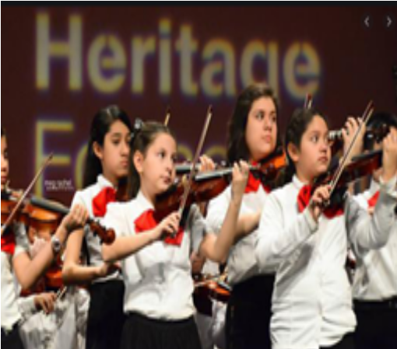

Dates to
Remember
October 2020

Your monthly guide to school news, information & events.
Calmeca Academy

